Relativity Legal Hold Post-installation verification test
November 22, 2021

Overview
To verify that your Relativity Legal Hold 10.0 application is functioning properly after an initial installation, complete the following post-installation verification tasks in order.
This document assumes that email and Portal settings have already been configured under the Custodian Settings tab. Also note that if you are using the LDAP import functionality to import entities from your Active Directory server, you must install the Relativity application, “Relativity Integration Points.”
Access Relativity Legal Hold
☐ Log in to the Relativity Legal Hold workspace using your credentials.
Entity tab
☐ Create a new entities, “Jane Smith”, and fill in required fields marking department as “HR.” Use your email address in the Email field.
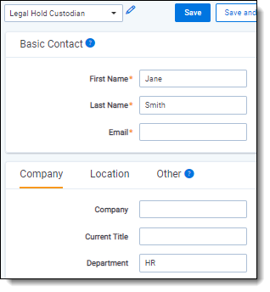
☐ Create a second new entity, “Blake Kensington” with email “bkensington@relativitysmoketest.com.”
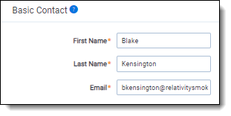

Legal Hold Projects tab
Create a new project (not from an existing project template).
☐ Click “New Project” and create it from the Legal Hold Template. Select “No” in the Use Wizard field.
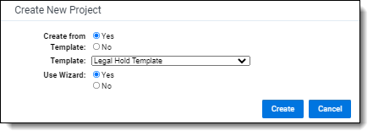
☐ Name the new project “Smoke Test” and click “Save” at the top
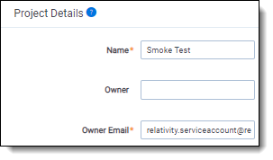
☐ Click the Assign button and assign Blake and Jane to the project.
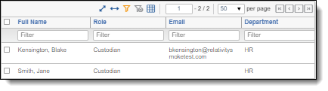

☐ At the bottom of the projects page, click into the “Legal Hold Notice Template” communication and Edit.
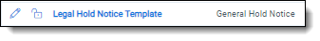
☐ In the Portal Content sub tab:
☐ Make sure that acknowledgement is required.
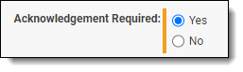
☐ Click into the Legal Hold Questionnaire Template:
☐ Change the name to “Test Questionnaire”.
☐ Edit the condition for Question 2A and configure the condition to send the Alert Notice Template Communication (from the Smoke Test project) to Jane Smith if the question is answered “Yes”.
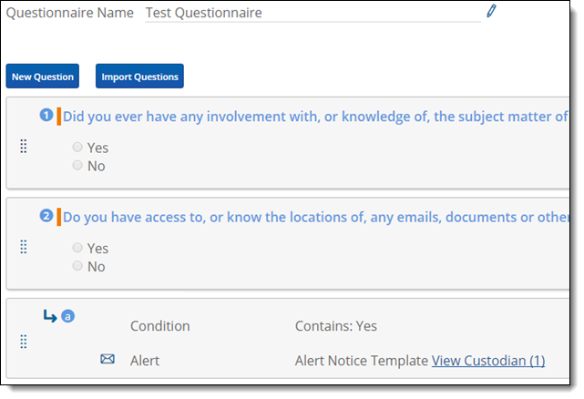
☐ Click Done.
☐ In Email sub tab:
☐ Send the email as TestReplyWithQuestions@<yourdomain>.com
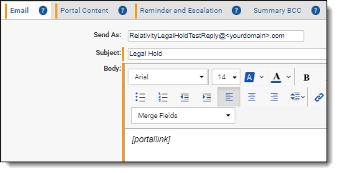
☐ Click Save at the top.
☐ Click the Send Communications button inside the hold notice communication to open it.
☐ Send the communication to Blake and Jane.
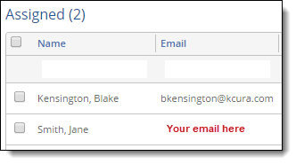
☐ Confirm that you received the email that was sent to Jane Smith.
Global Reminder tab
☐ In the Global Reminder tab:
☐ Click Edit.
☐ Update the Subject to be “Test Global Reminder”. Update the Body to be “You are on an active hold. Please [PortalLink] to review your current list of active holds.”
☐ Click Save and then Send Global Reminder Now. Ensure that your email (Jane Smith) receives this Global Reminder and that you can successfully click the link to access the Portal.

Entities tab
☐ From the Entities tab, filter for Name: “Kensington, Blake”
☐ Click into Blake Kensington’s profile and click Edit.
☐ Click Use Portal As.
☐ Click the “Test Hold Notice” task under Tasks Requiring Attention.
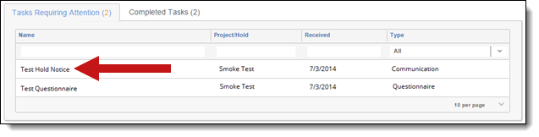
☐ Acknowledge the hold, specifying the reason as, “This is a smoke test.”
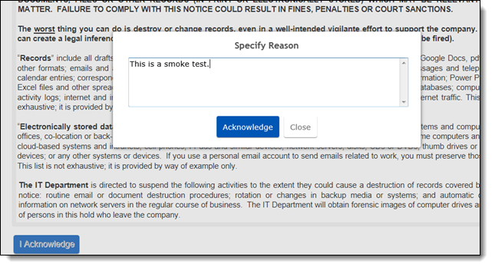
☐ Continue to the questionnaire and select Yes for both questions before submitting.
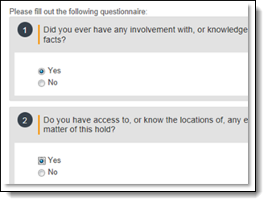
Verification
Verify that you received the alert notice communication that was sent to Jane Smith.
Reports tab
☐ Run the Communication Summary report against the Smoke Test Project.
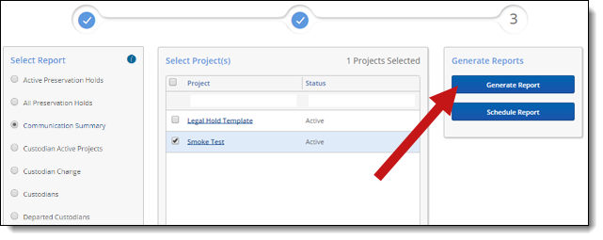
☐ Export the results to XLS files.
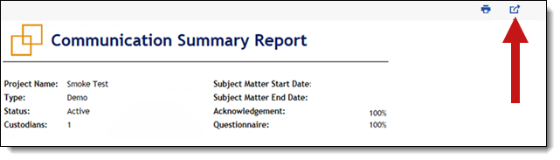

☐ Print the results.
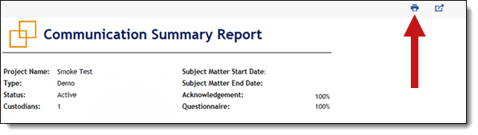
☐ Verify that the scheduled report is delivered to you via email when the scheduled time runs. After verifying, delete the scheduled report.

